Drop-Down Lists are also referred to as Value Lists in FileMaker Pro. Value lists are lists of data values that are linked to a field. The purpose of a value list is to provide a list of choices in a drop-down list for the user when performing data entry.
- File/manage/value lists

- Click NEW button

- In Value List Name, type: title

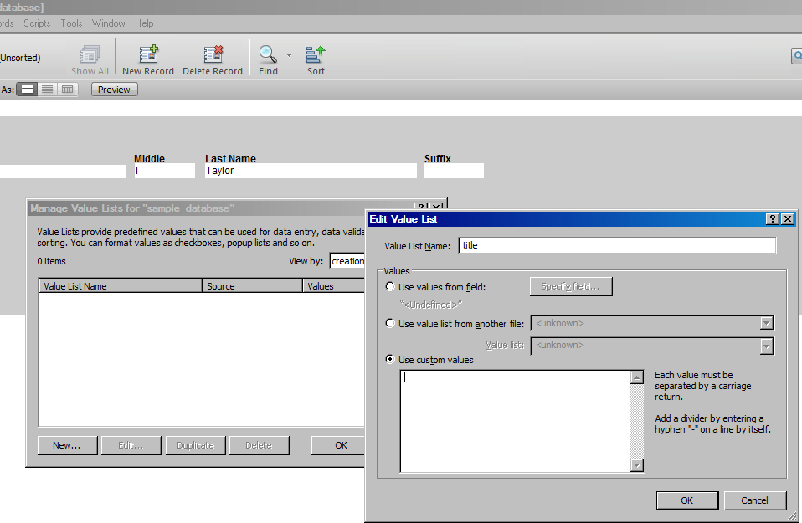

- In Use custom values box, type the list of titles (pressing Enter key after each one).
- Click OK twice.

- Repeat steps 1-4 for the suffix drop-down list:
  - Value List Name, type: suffix
  - In Use custom values box, type the following, pressing enter after each one:
      - Jr. Sr. II, III, IV
- Return to Layout Mode.

- Click the name_suffix field.
- Use the Inspector/Data tab.
- Control style arrow, select Drop-down list.
- Select “Suffix” in “Values from“ drop down arrow.

- Select checkmarks for:
  - Include arrow to show and hide list
  - Allow editing of value list

- Do the same for the title field.
  - Click the title field
  - Use the Inspector/Data tab
  - Control style arrow, select Drop-down list.

- Select “Title” in “Values from“ drop down arrow.

- Select checkmarks for:
  - Include arrow to show and hide list
  - Allow editing of value list

- Change to Browse Mode.

- Click Save (when prompted).

- Click title and suffix - Notice the drop-down list is populated with the values you typed.

